**FARM BUILDINGS AND STRUCTURES**

There are constructions made in the farm for various functions. Examples of farm structures are;

* Buildings (stores, offices, cattle dip, spray race, crush, animal house).
* Water storage structures (dam, boreholes, tanks, reservoirs).
* Fences (Barbed wire fence, plain wire, woven wire fence, electric fence, wooden fence, trench fence and live fence.)

**Fence;** this is a structure made of various materials that is put around an area on boundary of land to restrict movement from one direction

**Importance of fence;**

* Can act as a boundary for the farm hence reducing land disputes over a boundary.
* Fences can keep out intruders on the farm. The intruders can be thieves, stray animals, wild animals and trespassers.
* Can facilitate rotational grazing in the farm by dividing up the farm into paddocks.
* Double fencing is very effective in controlling ticks (vectors) on a farm.
* Live fence can act as windbreaks hence controlling wind erosion and destruction of farm structure.
* Paddock fence makes it easy to control farm animals through confinement, separation and restraining.
* Ensures controlled grazing through construction of paddocks.
* Fence can facilitate controlled breeding by making it easy to separate animals according to sex and breed.
* Water points can be controlled with the help of fences.
* Crops are protected for animals damage during mixed farming.
* Controls spread of diseases from the outside farms.
* Live fence can make the farm to look beautiful.
* Fences can increase the value of the farm since they are assets.

**Factors that may determine the type of fence to be used.**

* Availability of capital; with enough capital, expensive fences like electric fences can be used.
* Topography; hilly places may not favour trench and concrete fences since they can be easily damaged.
* Animals to be confined/use; small livestock like goats, sheep, and poultry can be confined in woven fence but not barbed wire.
* Skills of the farmer; highly sophisticated fences like electric fence can only be handled by skilled people.
* Farmer’s interest; some type of fences may be highly preferred by the farmer hence used on a farm.
* Maintenance costs; fences with high maintenance costs are least preferred by farmers.

**Types of fences**

1. **BARBED WIRE FENCE.**

It’s a type of fence that uses a barbed wire hanged on posts to prevent animals from straying. It’s used in confining big livestock like cattle.

**Components of a barbed wire fence**

1. Posts (strainer, dropper, standard and strut)
2. Barbed wire (high tensile and low tensile)
3. Staple/U-nails.
4. Metal caps.
5. earth or concrete

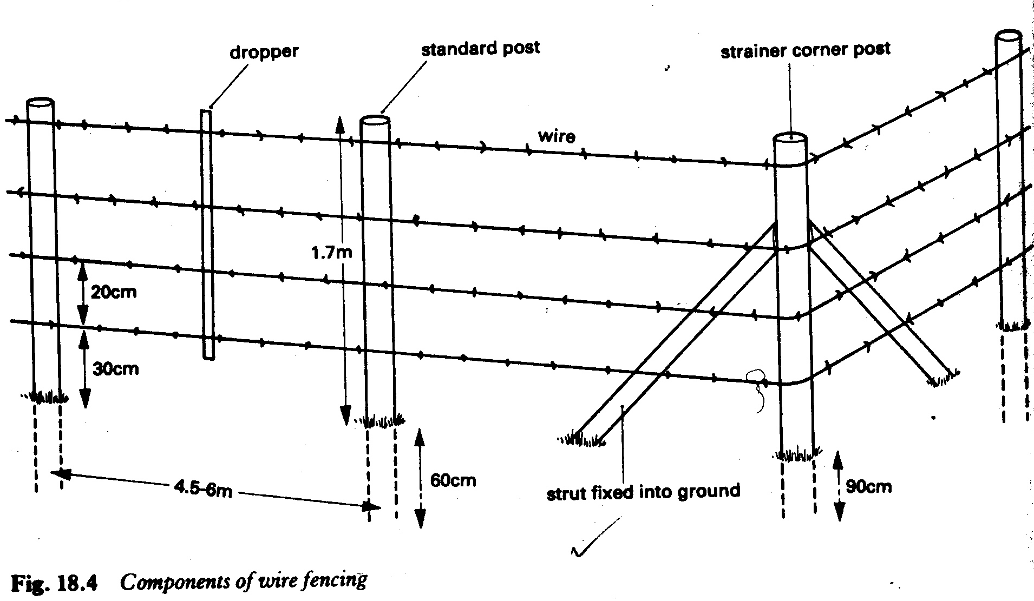

**Posts;**These are of 4 types and made of wood;

**Strainers/king post;** these are large posts put at the Corners and gates. They resist the pull of the wire from one direction.

**Strut;** smaller than the standard and strainer posts; they give support to the strainer

**Standard/ordinary posts**; bigger than struts and droppers. It holds the wire in position for efficiency and pulls wires in both directions.

**Droppers;** they are the smallest posts; they are hanged between wire strands to prevent the wire from sagging.

**Barbed wire;** It’s a wire having barbs at intervals.

**Types of barbed wires**

* Low tensile barbed wire
* High tensile barbed wire.

**Low tensile barbed;**

* + It’s thick (big barbs and wires)
  + Its long lasting
  + Does not sag easily
  + Rusts easily
  + Breaks easily

**High tensile**

* Its thin (has small barbed wires and barbs)
* Does not break easily.
* Can resist tensile forces
* Stretches to cover a big area during fencing
* Does not rust easily.

**Staples/U-nails;** it attaches the barbed wire onto the post.

**Metal caps;** Cover the top part of the post to prevent rain damage.

**Concrete / earth;** Used for making the posts firm in the ground

**Raising a barbed wire fence;**

* Select the area for fencing.
* Clear vegetation from the area where the fence line is to pass to a width of 2m to provide enough working area.
* Use a string to set out a straight line for the fence.
* Use pegs to set out positions for posts at about 4 mtrs for standard posts.
* Dig holes of about 2 feet (for standards) and 3 feet (for strainers) deep and big enough.
* Determine the number of gates and corners for easy calculation of posts required.
* Fit the posts into holes beginning with the strainers in corners and gates.
* Ensure that the post is 2m high above the ground.
* Pour concrete or soil in the hole after placing the post.
* Firm the soil/concrete to ensure that it holds the post firmly.
* Fix the struts on the strainers at the corners and gates.
* Stretch out the barbed wire at one end using a wire strainer.
* Staple the first strand of the wire on the posts.
* Add more strands depending on the type of animals to be confined/purpose.

**Equipment used in raising a barbed wire fence**

String, measuring tape, claw hammer, wire strainer, U-nails/staples, concrete, hole digger, cross cut saw or bow saw.

**Disadvantages of using barbed wire fence.**

* Can damage hides and skins.
* It’s expensive to raise and maintain.
* Requires a lot of labour to erect.
* Land divided up in paddock may be difficult to mechanize fully.
* They discourage selective grazing which is of advantage to livestock.

**Methods of treating posts**

1. Sap displacement
2. Vacuum / pressure treatment
3. Hot and cold soaking
4. Cold soaking

**Sap displacement**

**Procedure;**

* Peel off the bark from freshly cut posts.
* Immerse the post at the bottom end into a preservative for 5 days.
* As sap in the post evaporates, its space is taken up by the preservative.
* After 5 days invert the post so that the other end comes into contact with the preservative.
* After five days, remove the post from the preservative and allow it to drip dry while under a shade.
* Put the posts in a good store before selling to protect it from thieves.
* Preservative used is Tanex or celcure A

**Vacuum/Pressure treatment**

* Poles/posts are peeled to remove the bark.
* Poles/posts are parked in a large cylinder
* the cylinder is sealed up and pressure increased inside it
* A chemical is forced into the posts at high pressure.
* The cylinder is opened and the posts removed.
* The posts are allowed to dry outside before use.

**Hot and cold soaking**

* Peel the posts/poles to remove the bark.
* Immerse the poles/posts fully in the preservative.
* Heat the preservative with poles inside to near boiling point for 2 hours.
* Heating causes cells to expand.
* Cool the preservative to allow the plant cells to suck in the preservative.
* Remove the poles from the preservative and allow it to drip dry under a shade.
* Prepare the poles for use.

**Cold soaking**

* Poles are peeled to remove the bark.
* They are immersed fully in a preservative for 1-3 days.
* The preservative is drawn into the poles/posts.
* The posts/poles are removed from the preservative and allowed to drip dry.
* Posts are placed in a shade ready for sale.

**Seasoning of timber**

* Provide a shade to keep off sunshine and rain.
* Heap the timber in stacks.
* Support timber off the ground to allow air circulation beneath.
* Separate pieces of timber with wooden rods to allow free air circulation.
* Closely space the support sticks to avoid wrapping of the timber.
* The stacks should be parallel to the ground to avoid sliding and bending of timber.
* place heavy materials on top of the stack to stop the timber from bending

**Advantages of using wood.**

* 1. It is readily available in most areas.
  2. It is relatively cheap to buy
  3. It is light to lift during work.
  4. Easy to cut into required shape and size.
  5. With good treatment, it can last long.
  6. It’s a good insulator against heat and electric shocks.

**Disadvantages**

* 1. They are highly susceptible to attack by pests if not treated.
  2. Can easily decay under moist conditions due to fungal attack
  3. They are a fire hazard.

1. **ELECTRIC FENCE**

A fence that depends on mild electric current flowing in wires to keep off animals.

The main components are posts, insulator and facing wire, power source and control unit.

**Raising an Electric Fence**

* Clear the area where fence line is to pass to a width of 2m.
* Measure off the distance required for each post.
* Dig the holes to accommodate the posts and over it.
* Place the posts as required.
* Install the other equipement as required.
* Ensure good earth connections for efficiency.

**Challenges of using an Electric Fence**

* Requires a lot of skill to install.
* Has a high maintenance cost.
* Works best only in humid conductions.
* Equipment is expensive to buy.
* Continuous shocks frighten the animals reducing productivity.

**3 LIVE FENCES**

Its barrier of tree or shrubs in rows that is thick enough to prevent penetration by animals or intruders.

The common shrubs used in making live fences are Kie apple, sisal, tick berry, ficus, and cassia.

**Advantages of using live fences**

1. Planting materials can be obtained locally hence cheap.
2. Can add beauty to the farm.
3. May act as wind breaks.
4. Has a low maintenance cost.

**Limitation**

1. Difficult to establish under harsh environmental conditions
2. They take long to establish
3. Shrubs become uneffective at the bottom where branches are few.
4. May compete with crops for nutrients.
5. Some hedge plants are poisonous to animals.
6. Some harbour pest that attack animals and crops
7. Cannot be used effectively to subdivide land into paddocks for grazing

**Factors that affects effectiveness of hedges**

* Age of the plants; at a young age, they may have less branches and hence less effective.
* Level of branching; poor branching makes it uneffective.
* Nature of spacing; lose spacing leads low effectiveness and vice versa.
* Morphology of the shrub; plants with a lot of branching shows more effectiveness.
* Fertility of the soil that influences growth of the shrubs has a high influence.
* Environmental condition; drought may dry the shrubs making it less effective.

**4 CONCRETE/STONE/WALL FENCE**

It can be made up of concrete or bricks/blocks that make up a wall. It’s used for small enclosure.

**Advantages**

* Efficient at controlling intruders.
* Does not harm animals
* Has a low maintenance cost.
* Resistant to harsh weather once constructed properly.
* Can confine small livestock.

**Disadvantages**

* Very expensive to construct and maintain.
* May prevent proper air floor into the farm.
* Can be destroyed by water in poorly drained soils.

1. **WOVEN FENCE**

Plain wire is woven into different patterns to make a sheet of wire mesh. The fence is good for confining small animals though can work for big animals.

**Advantages**

* Easily confines small animals
* Does not damage the hides and skins.
* Can restrict movement of a wide range of intruders including people.

**Disadvantages**

* It s very expensive to buy wires and install

**Animal handling structures**

* Crush
* Spray race
* Cattle dip
* Milking parlour/ shade

**Crush**

It’s a farm structure used for restraining animals during farm operations. It has a collecting yard, inlet, draining yard and out let. It can be made from wood or metal bars. It can confine animals during

* Hand spraying to control ticks.
* Artificial insemination
* Administering oral and intravenous drugs
* Identification of animals
* Dehorning
* Taking the animal’s temperature.
* Milking
* Pregnancy diagnosis.
* Physical examination of the animal.

**Spraying the animal in a crush using a bucket pump, knap sack sprayer or plantector pump. Order of spraying BBBRH (Back, belly, brisket, rear and head)**

* Spray the back from shoulders to the tail head.
* Spray the sides and flank in a Zigzag motion so that excess wash on the back can be retained by wetted flanks.
* Spray the belly with the nozzle facing upwards for a good coverage.
* Spray the udder or scrotum carefully.
* Spray the brisket, legs, between the hooves, heels, dew lap and neck.
* Spray both hind legs including the heels and between the hooves of hind legs
* Lift the tail and spray underneath ending with the switch.
* Hold the tail along the animal’s back and spray the switch again.
* Spray the head, poll, face, base of the horns and muzzle.
* Spray inside the ears without putting the nozzle close to the ear.
* Allow the animal to move to the draining yard to drip dry before being let out.

**Advantages of using a bucket spray pump.**

* Its simple to operate i.e. requires less skills
* It has low maintenance costs due to few delicate parts
* Can be used for a long time without breaking down i.e. its robust/durable.
* It’s cheap to buy.
* Its highly mobile hence can be operated in different parts of the farm.
* Does not require power hence good for remote areas without electricity.

**Demerits**

* Its labour intensive i.e. requires a lot of labour.
* It may not easily spray crops in garden since it cannot be moved.

NB: The main purpose of sprayers is to provide maximum coverage and use of less pesticide.

**Working of a bucket spray pump.**

* Place the acaricide in the bucket.
* Dip the barrel in the acaricide until the valve and strainer are fully immersed.
* Place the leg and foot out of the bucket.
* Place your foot on the foot of the pump while holding the handle.
* Ensure that the hose pipe is well connected to the delivery hose.
* Use the right hand to hold the handle while the left should hold the lance handle trigger control.
* Move the handle up to suck the acaricide and down to deliver it to the hose pipe.
* Use the trigger to control the acaricide released through the nozzle during spraying.

**Merits of using a plantector pump.**

* Cheap to buy
* Cheap to maintain
* Easy to operate
* Light to carry i.e. highly portable.
* Can be used to spray crops and animals.
* Can be used in watering crops.

**Maintenance of sprayers**

* Use clean water/acaricide in the sprayers to reduce blockages.
* Ensure that leakages on the hose pipes are repaired.
* Replace all damaged valves regularly.
* Regularly Oil the parts that require oiling.
* Wash the sprayers after work to reduce corrosion by the chemicals.
* Regularly unblock the nozzles, pipes; filters and hoses.
* All rubber parts should be well washed and stored in cool dry place.

**Merits of using a crush in vector control.**

* Dip wash used is always fresh hence have high chances of being effective.
* It handles all animals including those at advanced pregnancy and sick.
* Cheap to construct hence good for peasants farmers/small farmers.
* Less chances of disease spread through acaricides.
* Allows a farmer to physically assess the level of pest infestation in livestock.
* Does not require animals to move for long distances since it can be easily constructed at the farm.

**Limitations of using a crush**

* Its labour intensive hence increasing costs on the farm
* Its slow hence cannot ably handle large herds.
* Wastage of acaricide since it cannot be reused.
* Coverage of the animal with acaricide may not be adequate.

**Procedures of spraying animals in crush.**

* Mix the acaricide with water in right proportion before hand.
* Drive the animals to the collecting yard of the crush.
* Lock the entry using sliding tail bar.
* Lock the outlet with the sliding bar to confine the animals.
* Start spraying the animals following the BBBR
* After spraying open the outlet and lead the animals to the drain yard.
* Close the outlet and open the inlet to allow in another group of animals.
* Release the animals from the draining yard after dripping dry.
* Repeat the same procedure until all animals are sprayed.

**Spray race.**

It’s a structure with motorized sprayers that shower animals with acaricide from all directions. Spray race is made up of the following.

* Side wall and roof
* Spray pipe system with nozzles
* Guide rails
* Delivery pipe
* Control valve
* Sump/reservoir
* Agitator pipe
* Suction pipe
* Pump/driving engine
* Drainage pipe
* Pressure gauge
* Sieve
* Foot valve down in the sump.

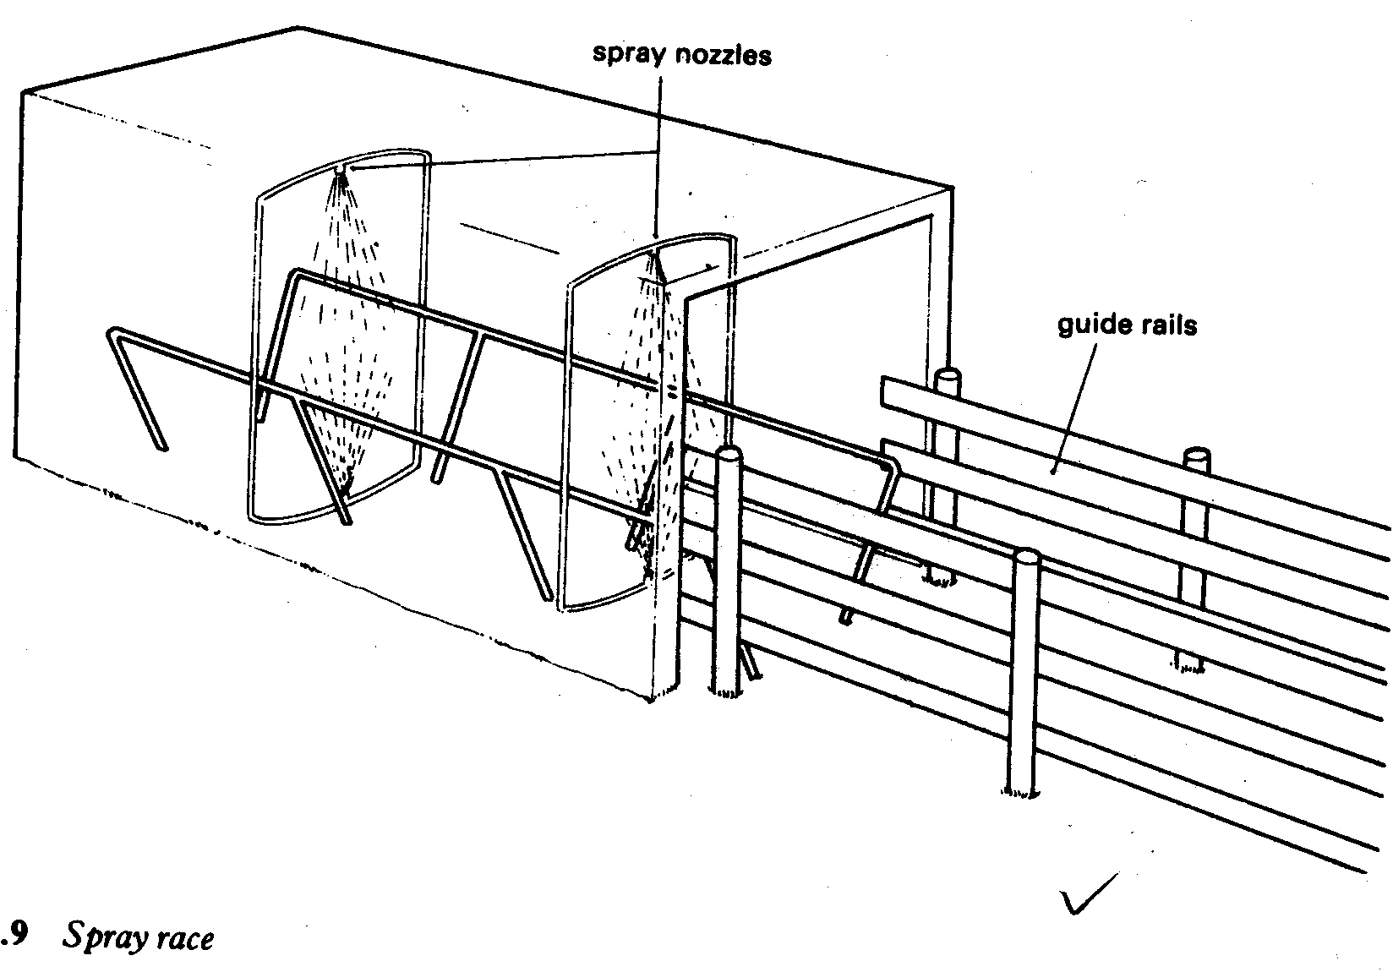

**Working of spray race.**

* Animals are driven into the race (between walls and roof) after washing their feet in the foot bath.
* The Sump is filled with the acaricide to be used.
* The engine is switched on so that the acaricide can be pumped through spray pipe system and delivery pipes.
* As the acaricide flows through the agitator, pressure is increased due to the small size.
* It’s delivered to the nozzles fitted at various points in the race.
* The nozzles deliver the acaricide to the animal’s body at high pressure.
* Excess acaricide from the animal’s body is drained back to the sump through the drain pipe.
* The acaricide is filtered by the sieve before going back to the sump.

**Management of animals in a spray race to ensure effective spraying**

* Animals to be sprayed should be arranged in a single file as they enter the race.
* Effort should be made to lift the animal’s tail.
* Thick hair in the ears and switch should be clipped for proper acaricide coverage.
* Animals being sprayed for the first time should be run through the spray race without spraying for acclimatization
* Pump out the excess wash/acaricide to the excess pool.
* Wash the unit clean immediately after spraying.
* Leave some water in the sump to prevent it from cracking.
* Close the return wash pipe at the exit to keep out rain water.

**Advantages of using a spray race.**

* Quick and hence can handle large numbers of animals.
* Can handle small animals since they may not have to swim.
* Can handle sick and pregnant animals easily.
* Reusing the acaricide reduces wastage.
* Acaricide is used when fresh hence more effective at controlling ticks.
* It does not require much labour
* Initial cost is higher but cheaper in the long run.
* Spread of diseases through the acaricide is not witnessed here

**Limitations of using a spraying race.**

* Require a lot of skills to operate.
* Blocked nozzles may make spraying uneffective
* Its only economically viable for farms with large herds.
* Consumes a lot of power increasing farm costs.

**Cattle dip.**

It’s a farm structure with a tank in full of dip wash in which animals are immersed to control external parasites like ticks. The cattle dip has a capacity of 13,000-22,000 litres of dip wash while goat/sheep dip has a capacity of 2000-2500 litres.

**Factors to consider before construction of a cattle dip on a site.**

* The site must have abundant water supply for use in mixing acaricides and washing the dip.
* The site must be having a firm ground to prevent the dip tank from sinking.
* Area must be well drained as flooding may dilute the dip wash.
* The site must be big enough to accommodate the dip and accessories.

**Features of a good cattle dip.**

* Collecting yard; - It’s where animals are collected and confined before being led through the foot baths to the dip tank.
* Guide rails; - These keep the animals in one place by acting as a barrier.
* Foot baths; - These are two in number and it’s were the animals hooves are cleaned to reduce contaminations of the dip wash.
* Roof: - Reduces evaporation of the dip wash during drought and diluting of dip wash by rain water.
* Dip tank: - Made up of strong reinforced concrete and acts as a reservoir for the dip wash.
* Dip wash: - Diluted acaricides in which animals are immersed.
* Jump off point/entrance ramp: - It’s a slippery and sloppy surface which leads animals into the dip wash.
* Strong walls: - This holds the roof in place and prevents the dip wash from splashing outsides as animals are immersed.
* Drainage race; - It’s where animals are retained temporarily to allow the excess dip wash drip of animals and get returned to the dip tank.
* Sloping exit; these are steps in the dip that allow the animal to walk out of the dip tank after immersion.
* Draining pipe; - It allow excess dip wash from the animals body to return back to the dip tank.
* Soak dip pit; - This is where dirty dip wash is drained during cleaning of the dip.

**Management of animals during dipping.**

* Animals to be dipped should be given water first so that they do not drink the acaricide due to thirst.
* Dipping should be a fixed routine never to be changed or interrupted to control disease spread.
* Dipping should be done at the cool hours of the day to reduce chances of animals drinking the dip wash due to.
* The first 10-15 animals should be run through the dip to stir up the acaricide and then re-dipped for the second time.
* Ensure that the foot bath has clean water to wash the feet hence reducing acaricide contamination.
* Arrange the cattle in single file and allow it to enter the dip one at ago.
* Sick animals and those at advanced pregnancy should not be dipped.
* Adult animals should be dipped separately from young ones.
* All animals on the farm should be dipped to reduce spread of vectors.
* All animals dipped should be recorded to ensure that all are dipped.
* Foot bath and yards should be cleaned after dipping.
* Seal off all the entrances into the dip to stop animals from entering it when not right.
* Use a long stick with a “Y” junction to push the head of the animal into the dip wash to ensure that it is fully immersed.

**Maintaining a cattle dip efficiently functioning**

* Test the strength of the acaricide during dipping to take action before the next to dipping.
* Ensure that the collecting yard floor is made up of concrete to reduce mud into the dip.
* Fill the footbath with clean water to ensure that mud is removed from the animal’s feet.
* Sedimentation sump should be provided to sieve the dip wash so as to remove dirt from dip wash.
* Proper plugging of draining pipe after dipping to stop rain water from returning to the dip tank to dilute the dip wash.
* The roof provided should be leak proof to reduce dilution of the acaricide during rain and evaporation of the acaricide during hot whether.
* Monitor the dip tank to ensure that there are no cracks at the bottom or repair cracks to reduce leakage.
* Stir up the dip wash before dipping the animals to ensure a uniform concentration.
* Keep the concentration of the dip wash higher in rainy season since it gets diluted easily.
* Periodically replace the dip wash once it becomes uneffective.

**Challenges of using cattle dip.**

* Excess fouling and sedimentation.
* Flooding during heavy rains.
* Evaporation of dip wash during hot whether.
* Leakage through cracks at the bottom reducing volume.
* Inefficient stirring of the acaricide before dipping.
* Decomposition due to bacteria.
* Inaccurate analysis of dip wash samples which may affect efficiency.
* Using dip wash for a long period of time until it becomes uneffective.
* Dip wash becoming muddy during the rainy season.

**Advantages of using a dip**

* Animals are fully immersed in dip wash for effectiveness.
* Allows a large number of animals to be handled in a short time.
* Dip wash can be used over and over a gain reducing wastage.
* Requires less technical skills as compared to spray race.
* Costs of construction are spread all over time making it cheaper in the long run.
* Its fast at vector control as it involves only immersing animals.

**Limitations**

* Too much dirt dilutes the dip wash making it less effective.
* Leakages at the bottom are difficult to detect and repair.
* Sick and animals at advanced stage of pregnancy cannot be handled in the facility.
* Viral diseases like foot and mouth disease can be spread through the dip wash.

**FARM BUILDINGS**

Materials used in building construction are wood, concrete, metal, bricks, stones, earth, bamboos and thatch.

**Wood;** may be used as timber for poles, posts, purlins, rafters, trusses, tie beams, face boards, frames for windows and doors, ceiling etc.

**Concrete;** this is a mixture of cement, sand and aggregates (small stones)

***Uses***

* Wall construction
* Construction of wall plate
* Construction of floor
* Making concrete blocks
* Making pillars
* Joining blocks.

**Making Concrete**

Concrete is made using 2 methods

1. Mechanical Mixing
2. Machine mixing

**Mechanical mixing**

* Clear the area where the concrete is to be mixed by obstacles and vegetation.
* Make the place water tight by laying up mortar in advance.
* Measure cement, sand and aggregates in required ratios of 1:2:3 for blocks, floors and foundations or 1:1:2 for beams and pillars; 1:2:4 reinforced floor and engine foundations
* Spread the sand on the ground after measuring the required quantity.
* Spread the measured cement evenly over sand
* Mix the two items i.e. sand and cement evenly by turn each over and over.
* Spread the mixture of cement and sand on the ground once again after mixing.
* Spread the coarse aggregate over the mixture of cement and sand.
* Mix the aggregate properly with cement and sand.
* Heap the mixture and make a depression in the middle.
* Add water slowly in the depression that has been made in the middle of the heap.
* Use the spade to mix the materials with water until good concrete forms.

**Machine mixing**

* Obtain the concrete mixing machines.
* Measure the cement, sand and aggregates in the right proportions according to use.
* Pour the sand into the machine
* Add cement to sand in the machine
* Add aggregates to sand and cement.
* Add water to the mixture
* Switch on the machine and allow it to mix the concrete as required.
* Remove the concrete once fully mixed and switch off the machine.

**Advantages of using concrete in building construction**

* Its highly durable once mixed properly.
* Highly resistant to pest attack
* It’s cheaper than using metal in building construction.
* It’s highly resistant to fire damage.
* It’s easy to clean more especially after giving it a smooth finishing.
* It’s far stronger than wood.

**Disadvantages**

* It requires a lot of skill to make
* Very heavy hence may require a lot of labour to work.
* Cannot be easily recycled for moulding into other items.
* Materials used in making are highly expensive.
* May not be easy to repair once it develops cracks.
* Has low tensile strength hence cannot resist strain and stress forces.

**Bricks;** these are made out of earth mixed with water and moulded into the required shape and size using a wooden mould. It’s dried and burnt in a kiln to increase durability. They are used in making walls and foundations for farm buildings.

**Blocks;** they are made from mixture of cement which is coarse sand or concrete using a machine. They are stronger and bigger than the bricks. They are used in making walls and building foundations.

**Mortar;** this is a mixture of sand and cement in a ratio of 4:1. it can bind brick/blocks during construction. It can be used for plastering and finishing walls.

**Stones;** they can be broken into small aggregates for making concrete. It can also make hardcore used for foundations and floor.

**Earth;** can be used for making walls in form of mud. Can be used for making bricks. Once coated with mortar, the wall can last long.

**Bamboo;** can be used as building poles. split stem pieces can be used for making cribs for grain storage.

**Thatch;** its used for roofing instead of iron sheets and tiles. Its mainly dry grass, banana leaves or fibers.

**Metals;** these are used in making various parts of farm building, equipment and reinforcing concrete.

**Advantages of using metals**

* They are highly durable
* They can easily resist forces of strain and stress.
* They can be recycled and reused to make other implements.
* Are resistant to pest attack.
* Cannot be easily destroyed by fire.
* Can be used to perform several functions.
* It’s highly resistant to wear and tear.

**Disadvantages**

* They are heavy to lift during work.
* They are difficult and costly to cut into required sizes.
* They are more expensive to buy.
* It can easily rust reducing strength.

**Metals are able to resist the following stress forces**

1. Compressive stress; force which shortens the material.
2. Tensile stress; Forces which stretches the metal to increase length
3. Shearing stress; ability to resist the sliding of one material over the other.

**Strength of metals can be measured through the following**

1. Compressive strength; Resistance to forces that can shorten the metal through compressing.
2. Tensile strength; Ability to resist stretching forces that increases length.
3. Shearing strength. ability to resist wear and tear once rubbed against each other

**Description of metals**

1. Hard metal; One that resists cutting, abrasion and indentation.
2. Malleable; Can be shaped into different shapes easily without breaking or cracking.
3. Ductile; Can be made into thin wires by tensile stress.
4. Tough; Ability to withstand shocks and loads without deformation.

**Metals used construction of farm building and implements**

1. Cast iron; Engine blocks and other parts that require extra strength.
2. Wrought iron; has very little carbon and its used for making metals bars, nails and barbed wires.
3. Steel; contains some carbon. It is used for making tractor frames, plough beams, axles, cutting tools (cold chisel)
4. Copper; it is used for making electric wires, alloys of brass and bronze, tubes for fuel transport in engine.
5. Brass; an alloy of copper and zinc used for making bearings and electricity conductors, thermostats, water pump, fittings and sprayer nozzles.
6. Bronze; an alloy of copper and tin. Used for making ball bearings, valves, pump pistons and springs.
7. Tin; coats steel to make it resistant to corrosions. used in making dairy equipment like buckets and cans.
8. Solder; an alloy of lead and tin used for joining metals.
9. Zinc; it is resistant to rusting/corrosions hence used for coating (galvanizing) iron to protect it from rusting
10. Lead; used for making battery plates.

**Plastics;** these are polymers of ethene. They are of two types i.e. thermo softening and thermosetting.

1. Thermo softening can be heated to melt and get remolded into other items.
2. Thermosetting; cannot be remolded into other items after heating since they maintain their shape.

Plastics can be used in making tanks, cups, buckets, cans, strip cups etc.

**Advantages of using plastics**

* Some can be remolded into other items after heating.
* They are easy to colour making it more attractive
* They are light hence easy to lift.
* They are resistant to corrosions.
* They are cheap to buy.

**Disadvantages**

* Easily destroyed by fire.
* They are fire hazard
* Thermosetting plastics cannot be remolded
* Pollute the environment since they are not biodegradable.
* Weak hence not good for heavy duty since they easily break.
* Sun light can degrade it once exposed to it daily.

**Farm building**

**Importance**

* It protects farm animals against bad weather and pests.
* Protect farm equipment against bad weather
* Increases the value of the farm since they are assets.
* Makes management of farm animals easy and convenient.
* Reduces spread of diseases on farm by confining animals.
* It reduces loss of crop produce by protecting stored produce.
* Increase farm efficiency once used as offices.
* Protect farm produce and equipment against thieves.

**Factors determining the design of farm buildings**

* Capital available for the building to be set up.
* The use for the farm building.
* Size of production-higher production calls for big stores.
* Skills and knowledge of the farmer in designing farm buildings.
* Environmental conditions-like storms and strong winds.
* Nature of available technology that can be employed in building construction.
* Government policy on construction of building for various uses.
* Farmer’s interest as regards to building construction on the farm.
* Topography of the building site for the farm building.

**Characteristics of a good site for a farm building**

* Should be highly accessible so that goods can be easily brought in and taken out.
* Should have a reliable water source for use during construction.
* Should be well drained to prevent weakening of the building foundation by flooding water.
* Should have a good view in case the site is for the farmer’s house.
* The site should be secure to reduce theft of building materials and stored produce.
* Poor soils at the site are preferred so that the fertile soil is left for crop production.
* Should not face the direction of the strong winds.
* Should have a good power source to be used in the building.
* the site should be big enough to allow future expansions

**Making a farm layout**

A farm layout is a designed arrangement showing the position and location of specific physical and structural features in the farm.

**Factors considered in drawing up a farm layout**

* Existing permanent- If the area has another structure already there, then location may be altered.
* Topography-water tanks should be located on hills so that water can flow by gravity.
* Government regulations-It’s by law that livestock houses are located far away from human settlement to stop the spread of disease from animals to humans.
* Accessibility- Farm stores should be located near roads for easy transportation of produce into and out of the store.
* Soil fertility- Buildings should be constructed on poor soils so that fertile soil is left for growing crops.
* Security- Houses for small animals can be located near the farmer’s house for security reasons.
* Farmer’s interest – A farmer may prefer to put his house on a hill where he can observe what is taking place on his land.
* Size of land – Availability of enough land may encourage proper spacing of farm buildings.
* Water source-Animals houses must be constructed near a permanent water source.

**Qualities of a good house for animals**

* Should have strong walls to reduce chances of accidents to animals residing there after collapsing.
* Should have a concrete flow which makes cleaning easy.
* Should be big enough for all the animals to be housed so as to avoid over crowding.
* Should have a leak proof roof to prevent rain water from entering the building.
* Should have walls that are high enough to keep animals in the house.
* Should have enough windows to allow in light.
* It should have enough litter to absorb moisture and watering troughs.

**Quantities of a good building for farm machinery and equipment**

* Should be water proof to prevent rain water from damaging machinery.
* Should have good ventilation to facilitate easy cooling of machinery.
* Should have enough fire extinguishers to control fire incase of an out break.
* Should have enough space for all the machinery and equipment.
* Should be strong enough to resist the vibrations from the machinery or engines.
* Should be located near power source incase the machinery housed requires power.
* Should have emergency exist to act as escape route incase of an accident.
* Should be put in a place which is easily accessible by road.

**Quantities of a good crop store (crib, granaries and silos)**

* Should be rain proof to keep out rain water that can damage crop produce.
* Should be well raised above the ground to keep off damp conditions in the store.
* Should be well ventilated to allow drying of produce.
* Should have rat guards to keep out rats and other pests.
* Should have smooth walls without crevice to stop pests from hiding in the building.
* Should have strong door to safe guard produce from theft.
* Should have concrete floor which is easy to clean.
* Should be big enough to accommodate all the produce.

**Maintenance of farm building to increase durability**

* Make a good foundation for the building so that walls are kept strong.
* Use good rations for the construction materials.
* Plaster the walls to increase their strength.
* Provide a reasonable varanda to reduce contact with drainage water.
* Remove big trees a round the house since their roots can damage the house.
* Repair damaged parts of the building promptly.
* Make a wide foundation to increase surface area to support the supper structure.
* Providing proper drainage channels to remove excess water around the building.
* Destroy the vermin that can damage the building.
* Plant wind breaks on the wind ward side of the building to reduce damage by wind.
* Roofing should be done properly to reduce leakage that can damage the building.
* Fence the building to keep off animals that can damage the building.

**Major parts of a farm building (features of a good farm building)**

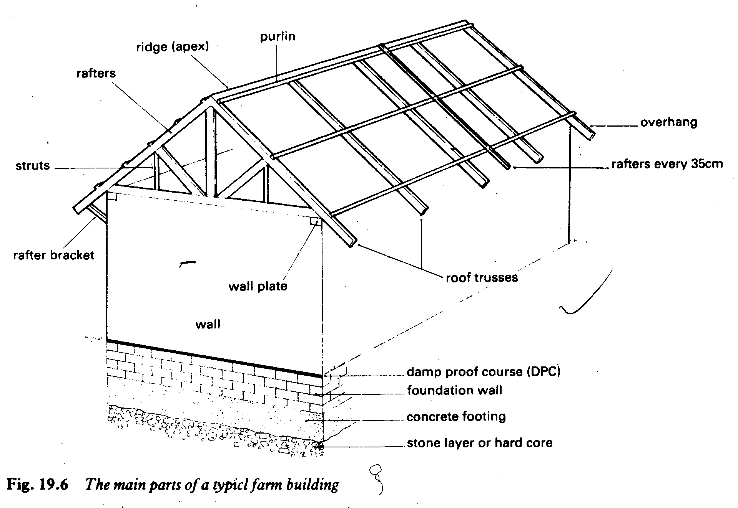

* Foundation (hardcore, concrete footing, DPC, foundation wall)
* Walls (wall plate, wall, windows, doors and ventilators)
* Roofing (purling, overhang, rafters, ridge, struts and (after bracket)

**Building foundations**

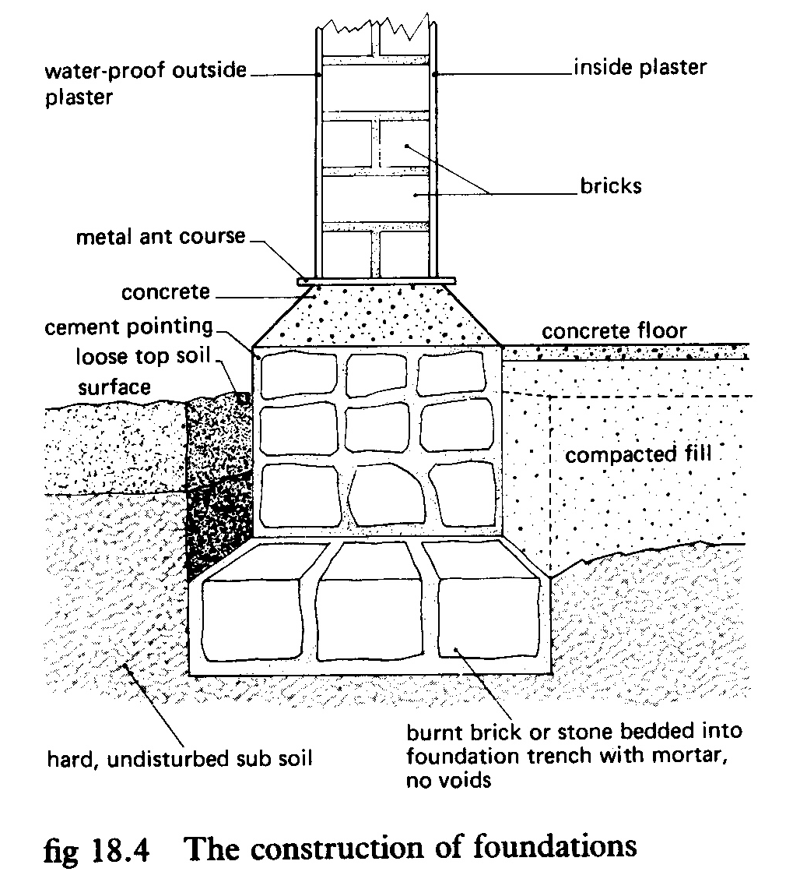

Part of the building which is a direct contact with the soil on ground, It is made up of;

Hardcore

Concrete

Damp proof coarse (DPC)

Foundation wall.

**Preparation of foundation**

* Remove all vegetation and obstacle from site.
* Set out the plan on the ground by using a try square for angles and measuring tape.
* Use pegs to locate the width of the foundation plan.
* Dig a trench for the foundation which is 35cm wide and 60 cm deep for the firm ground or wider and deeper for a wet site.
* Pour hard core stones at the bottom of the foundation and level it.
* Place a concrete on the hardcore mixed in a ratio 1:2:4 or 1:3:6 (cement; sand; Aggregate)
* Level the concrete laid with the help of a sprit level.
* Place bricks on the concrete and use mortar mixed to a ratio of 1:6 (cement; sand) to join the bricks.
* Make a brick wall (foundation wall) of about 15cm above the ground.
* Place a damp proof coarse (DPC) on top of the foundation wall. This stops water from rising up the wall by capillarity
* The foundation wall/plinth should be thicker than the building wall.
* Pesticides should be poured on the foundation to reduce pest damage to the building.

**Characteristics of a good foundation for a farm building**

* Should be large enough to avoid sinking of the building.
* Should be made of strong materials to support the dead load of the super structure.
* Should be deep enough to give more stability of the structure.
* Should have a damp proof coarse to stop water from rising the walls by capillarity.
* Should have a flat finish for easy start of the super structure.
* Should be well drained to prevent moisture from weakening the wall.
* Should be well reinforced to resist forces of tensile, compression and shearing form damaging the building.

**Dangers of having a poor building foundation**

* 1. Cracking of the super structure leading to reduced durability of the farm building.
  2. Seepage of water upwards weakening the walls.
  3. It becomes a home for pests like rodents that can attack stored farm produce.
  4. The building sinks reducing its durability.
  5. Collapsing of the building which may lead to loss of life and property.
  6. Wastage of construction materials due to constant repairs.
  7. Wastage of time and labour during repair of building.
  8. Deformation of a building making risky for use.

**Walls/super structure**

Part of a building between the foundation and roof. It can be made of bricks, blocks, mud and wattle.

It provides space for doors, window and ventilators

It should be strong enough to give support to the roof.

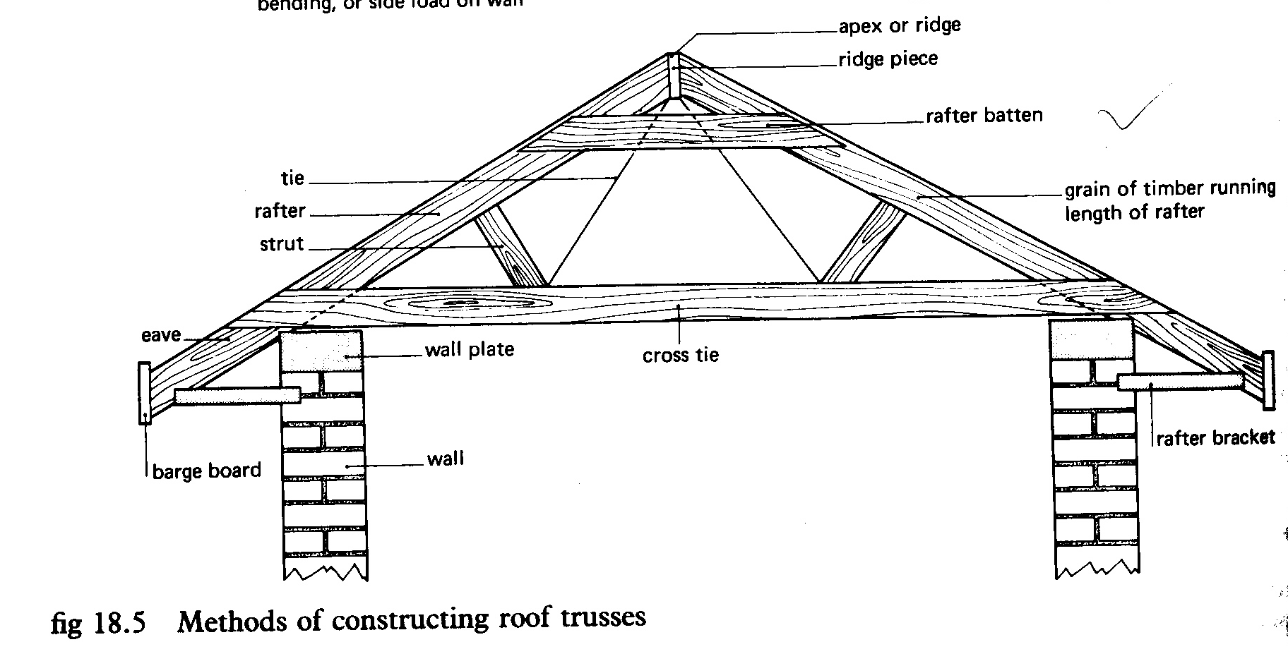

**Roof**

It’s the top part that covers the building to protect it from direct sunshine and rain into the building.

* Thatch - prevents water and sunlight from entering into the building from the top. It can be made of corrugated iron sheet, tiles, dry grass, dry banana leaves or fibers.
* Tie beam/cross tie supports the trusses and rafters above.
* Rafter - Form a triangular structure together with the tie beam.
* Trusses - It’s where the iron sheets are fixed.
* Struts – these give support to the rafters.
* Overhang – it’s an extension of the rafter that gives provision for the roof to cover the veranda.

**FARM WATER SUPPLIES**

**Sources of farm water;**

Precipitation i.e. rain, snow, hail etc is the ultimate source of all farm water. However, farmers collect water from different sources i.e. streams/rivers, lakes, wells, ponds, artesian wells, dams and reservoirs.

**Uses of water on the farm**

* For drinking by man and his animals.
* Water is used for feed mixing.
* As a solvent for mixing various solutions, suspensions or emulsions of farm chemicals e.g. pesticides.
* Water acts as a coolant because the evaporation of water from a surface leads to dissipation of latent heat of water vapourisation.
* Water is used for irrigation especially in arid and semi-arid areas to enable crop production.
* Water is essential in building for mixing of mud, making of bricks and mixing of concrete and mortar.

**Water shortages;** These are caused by;

* Inadequate rainfall
* Deforestation which increases soil erosion, silting up of water bodies and disrupts the water cycle.
* Drainage of water bodies
* Sinking of boreholes which lower the water table.
* Pollution of water sources which may make the water unusable for farm purposes.

**How farmers can fight water shortages;**

* Irrigation; The farmers can artificially provide water from other sources if natural precipitation is insufficient for the growing of crops and pastures.
* Afforestration and reforestation; The planting of trees helps to fight desertification by encouraging rainfall formation through evapotranspiration.
* Diversification of agriculture; This ensures that the farmer does not make a total loss in case of failure in one venture since the losses will be covered up by revenue from the other enterprise.
* Growing crops that fit in the rainfall regime; short maturing crops varieties have been developed that can be harvested before the rains stop falling in the regions with a short rain period.
* Keeping livestock that can tolerate drought; livestock such as goats, camels and donkeys may be kept.
* Agro-forestry; the trees provide shelter for crops and create a cooler microclimate in which the crops can grow even in periods of little precipitation.
* Construction of dams and reservoirs; farmers should find means to harvest the little precipitation whenever it is available to avoid wastage.
* Establishment of food reserves during the good harvests to cater for the drought periods.
* Insurance; farmers pay premiums into a pool out of which they are compensation in case serious drought causes losses to them.
* Using sunken seedbeds to ensure maximum infiltration of available water. The sunken seedbeds reduce runoff of precipitation and ensures that as much of it as possible remains in the garden.
* Pollution control and treatment of polluted water; this reduces the loss of water quality that may make some water unusable.
* Mulching of gardens especially in intensive farming to reduce the rate of evaporation and increase infiltration of rainwater by reducing runoff.

**Water storage**

Water may be stored in several structures i.e. dams, weirs, overhead tanks or rain water tanks. The type of water storage depends on;

* The distribution of rainfall; where the rain is evenly distributed through out the year, extensive storage systems may not be worthwhile.
* The source of water i.e. it may be rainwater where you need to collect it in tanks or a stream or river where you need to make a dam for it.
* The distribution method to be used to send the water to the other parts of the farm.
* A major use of the water i.e. is it for irrigation, animals etc. ponds may be constructed to collect runoff water for animals and irrigation but they may not be ideal if the water is required for human use.
* Availability of the building materials; dams are expensive to construct and require plenty of building materials.
* Maintenance costs of the storage structure.

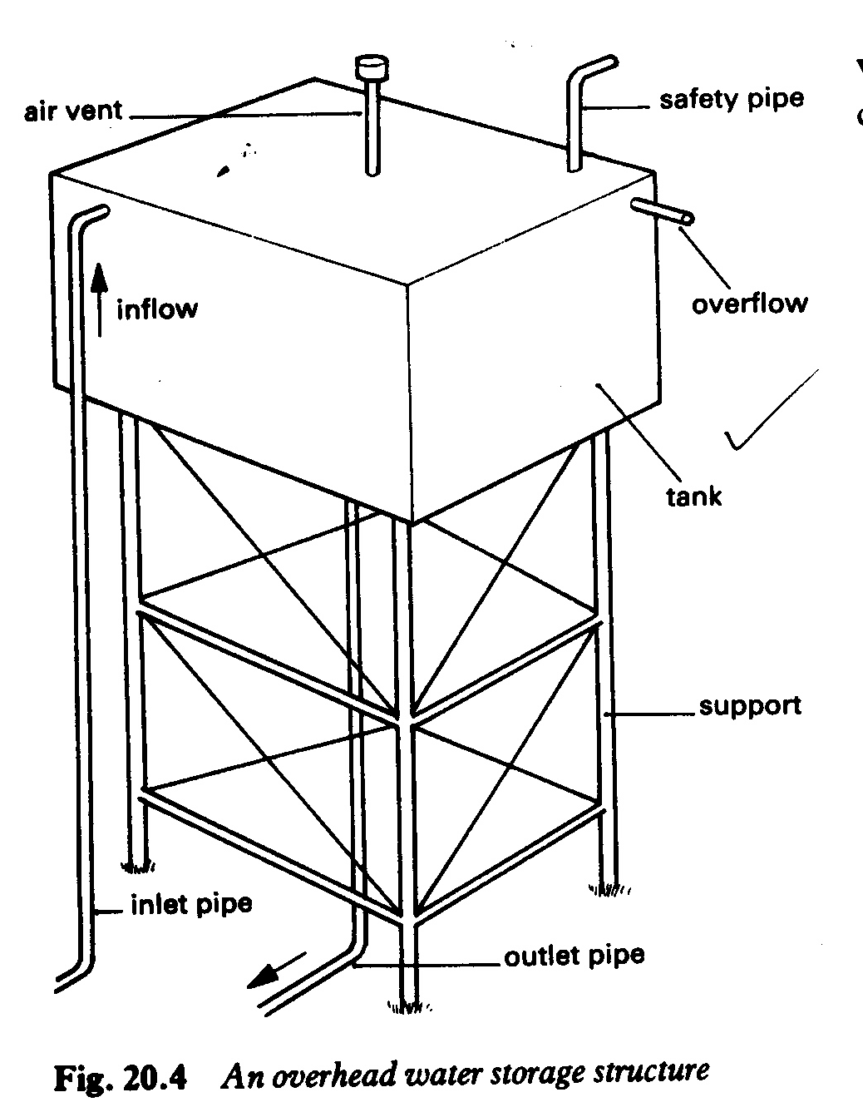

On a small scale, water may be collected from the roof of the buildings and stored in corrugated iron tanks, concrete tanks or plastic tanks. These tanks are either above or below the ground and should have a concrete base.

**An earth dam**

This is an obstruction along the natural flow of water in a stream or river. A dam is a wall or bank built to keep back or reduce the flow of water and so store as much as possible. Any excess water can be allowed to pass through some special openings or spillways as desired.

**Factors to consider when building dams/qualities of a good dam**

* Accessibility; the site should be accessible by man and his animals.
* Soil site; the soil should not be too permeable i.e. the soil should be firm and not sandy.
* It should make distribution of the water from the dam to the other areas easy.
* There must be a properly designed diversion or spillway to carry away excess water and prevent flooding or breaking of dam walls due to pressure.
* There must be reliable source of water e.g. a permanent or seasonal stream.
* It should not be easily fouled by animas through urination, defecation etc.

**A weir**

A weir is a structural device designed to raise the level of water of stream or river to a point above which the water begins to flow. Temporally or semi permanent weirs may be made from loose stones or logs held together by a weir net. More permanent weirs may be constructed out of concrete.

**Maintenance of farm water supplies**

* The sides of the ponds, springs and wells should have an appropriate lining of concrete or bricks to prevent contamination of the water by runoff.
* Dams, weirs and water reservoirs on the grounds should be surrounded by grass lawn to prevent siltation during heavy rainfall.
* Trees and shrubs should not be allowed to grow very near the water source as their roots may break the impermeable rocks under the water source and increase underground seepage of water.
* Water should be stored for a minimum of 2 days before use to allow sediments to settle and to reduce the bacterial content.
* Water for domestic use should be chlorinated or boiled especially if it is to be used for drinking.
* There should be proper sewage disposal on the farm to avoid contamination of the water source.
* Effluent from coffee factories and sewage systems should be properly treated before discharge.
* Water should be treated with copper sulphate to kill snails and control liver flukes.
* Remove silt regularly and clean the water source to maintain its capacity.
* Keep the pumps in good working condition to ensure proper supply of the water to other parts of the farm.
* Regularly inspect and seal all cracks in the walls or bricks work surrounding the water source or in the supply system to reduce loss of water.
* Remove aquatic plants that may block inlets and outlets and deposit organic matter which may reduce the capacity of the water storage facility.